**CSE 204**

**DATA STRUCTURES AND ALGORITHM**

**SESSIONALS**



**OFFLINE NO : ONE**

**TITTLE : TIME COMPLEXITY COMPARISON OF TWO SEARCH ALGORITHMS ON VARIOUS SIZES OF ARRAYS ( LINEAR SEARCH AND BINARY SEARCH)**

**SUBMITTED BY :**

**FAHMID - AL-RIFAT**

**STUDENT NO : 1705080**

LEVEL-2 ,TERM-1

DEPARTMENT OF CSE

BUET

**OBJECTIVE:** The objective of offline is to compare the time needed to execute the two famous algorithms binary and linear search where various size of array and and key are randomly generated for each time of execution .

**MACHINE CONFIGURATION:**

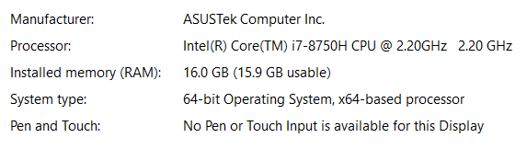

Compiler : Online Compiler GCC 8.1.1 ( jdoodle)

**DATA SET :**

**Table of search algorithm time in millisecond and array size:**

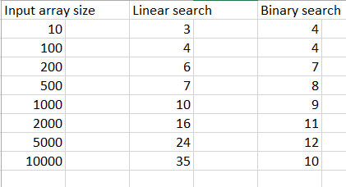

**DISCUSION :**

Binary search and Linear search are both are algorithm for finding a element in the list of finite elements . In the code arrays elements and key is generated randomly . In the linear search a traverse through all elements of the list until the desire element found . Its complexity so O(n) thus the result of the graph is linear and rising . On the other hand binary search algorithm always middle elements is targeted and array will divided into two halves of sorted arrays . So in these algorithm the steps for finding desire element lessen significantly which is in logarithmic scale which time complexity is O(logn) . So as the input array size increases the graph behaviour change significantly where in the initial they are quite similar

